**Welcome to the February 2018 PSHE/Healthy Schools Bulletin.**

**1. Health & Wellbeing Service Updates and News**

**A. Health & Wellbeing Service SLA**

**If your school has not signed up yet, why not have a look at what is on offer.**

[**http://www.leedsforlearning.co.uk/Services/2449**](http://www.leedsforlearning.co.uk/Services/2449)

**B. Healthy Schools**

If you want to get involved why not have a look at our new website. We now have over 260 schools engaged with 180 in Leeds. Click the link below to take you there

[](http://www.schoolwellbeing.co.uk/)

**C. My Health My School Survey 2017-18**



The My Health My School Survey went live in October 2017

This year we have undertaken a refresh of the information governance arrangements in light of the new Data Protection legislation - the General Data Protection Regulation (GDPR), which is due in May 2018. Due to this forthcoming change **we need all schools to re-register for the survey.** Also due to this new legislation the parent letter has been updated and all pupils will now need to give consent prior to starting the survey once they log in.

**Please note: your pupils will not be able to complete the survey until you have re-registered.**

 Last year we had a whopping **10,914** children and young people complete the survey from over **117 schools/academies** across the city. This equates to over a quarter of the Leeds pupils on roll population, which is a fantastic achievement!!

This year we aim to further increase both pupil response and the number of schools completing the survey which will enable us to further improve our citywide data and build on our **10 years of trend data.**

**What is the My Health My School (MHMS) survey?**

The **online survey** **is FREE** for all Leeds schools/academies. It asks questions relating to the Leeds Children and Young Peoples plan and aims to gather children and young people’s views, behaviours and choices in relation to their health and wellbeing and their school setting.

**Who can complete the survey?**

The survey is available for all Year 5, 6, 7, 9 and 11 pupils. In addition we also have a slightly amended version of the survey which is available to all Primary and Secondary Catholic schools in the city.

**What themes are covered in the survey?**

The survey covers the following key themes:

Healthy Eating/ Physical Activity, PE and Sport/Drugs, Alcohol & Tobacco/Sexual Health (Secondary’s only)/Social, Emotional & Mental Health/Safety & Anti-bullying and My School.

**How do I get access to the survey?**

Registering to complete the survey is quick and easy, just click [here](https://www.myhealthmyschoolsurvey.org.uk/registration)

**Please note: this year all schools need to re –register for the survey due to forthcoming changes in Data Protection legislation (see above).**

**Are there any supporting resources to help me implement the survey in school?**

Yes, there is a comprehensive resource page on the website (accessible to staff only) which includes a manager checklist, parent letter, pupil diary, glossary and three, one hour, easy to follow lesson plans which includes a preparatory lesson, a lesson to complete the survey (using individual computers under exam conditions) and a  plenary lesson. It is advised that for validity and reliability, the survey be completed at the same time each year.

**How do I access my school’s survey results?**

The registered school survey manager can access the results **instantly** after the pupils have completed the survey via the analysis page. To help you with this we have also created a quick guide on ‘how to analyse your data’ which can be found [here](https://www.myhealthmyschoolsurvey.org.uk/sites/default/files/filepicker/1/15.%20Accessing%20-%20Analysing%20The%20Results%202017-18.pdf).

Please do not hesitate to contact us at [Schoolwellbeing@leeds.gov.uk](mailto:Schoolwellbeing@leeds.gov.uk) if you have any further queries.

**D. PSHE and RSE Update**

**PSHE education supports academic success, says major evidence review (Dec. 2017)**

* **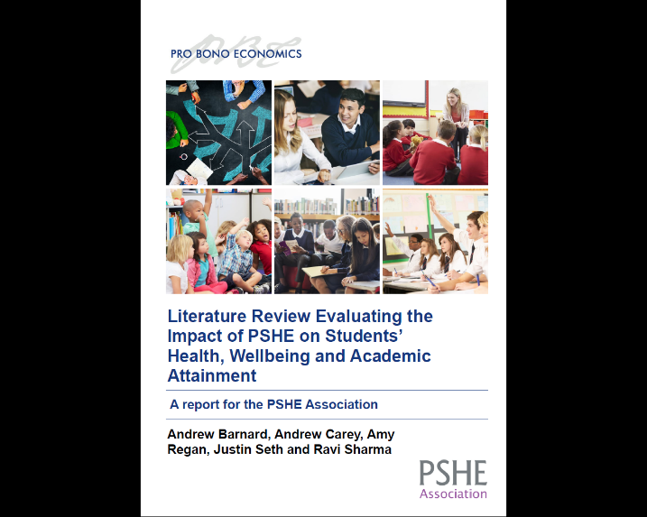*****We conclude that PSHE and PSHE-type interventions have a positive impact on both academic attainment and attendance. These effects vary and are a result of both direct and indirect links.***
* ***PSHE and PSHE-type interventions are effective in boosting academic attainment and attendance.***
* ***We found that the impact of some interventions are stronger in more disadvantaged areas.***

The Department for Education (DfE) launched [a ‘call for evidence’](https://consult.education.gov.uk/life-skills/pshe-rse-call-for-evidence/) on PSHE & RSE.

* The PSHE Association has welcomed this launch but emphasised the need for **statutory status to apply to the whole of PSHE education**, including, but not limited to, RSE.
* This year’s Children and Social Work Act included a commitment to ensuring RSE is taught in all secondary schools from 2019, ‘relationships education’ in all primary schools, and a **‘power’ to make the whole of PSHE education statutory** in line with other subjects, pending consultation.

Top 5 priorities for statutory PSHE education are that it should be taught:

* **regularly** – regular lessons on the timetable like other subjects
* **as a whole subject** – from sex & relationships to mental health, online safety to employability skills
* **by trained teachers** – PSHE covered in teacher training and ongoing opportunities to learn
* **in all schools** – all schools including academies and free schools
* **to all pupils** – from year 1 to finishing secondary school
* We’re pleased to see that the DfE are very keen to get young people’s views as part of the consultation as they will be the ultimate beneficiaries of positive changes to this area of the curriculum.

Although the consultation period is over the PSHE association believe the resources are still invaluable in gaining pupil views

**E. Public Health Resource Centre**

**Technorth**

**9 Harrogate Road**

**Chapel Allerton**

**Leeds LS7 3NB**

**Tel: 0113 2243174**

[**phrc@leeds.gov.uk**](mailto:phrc@leeds.gov.uk)

**F. Safer Internet Day**

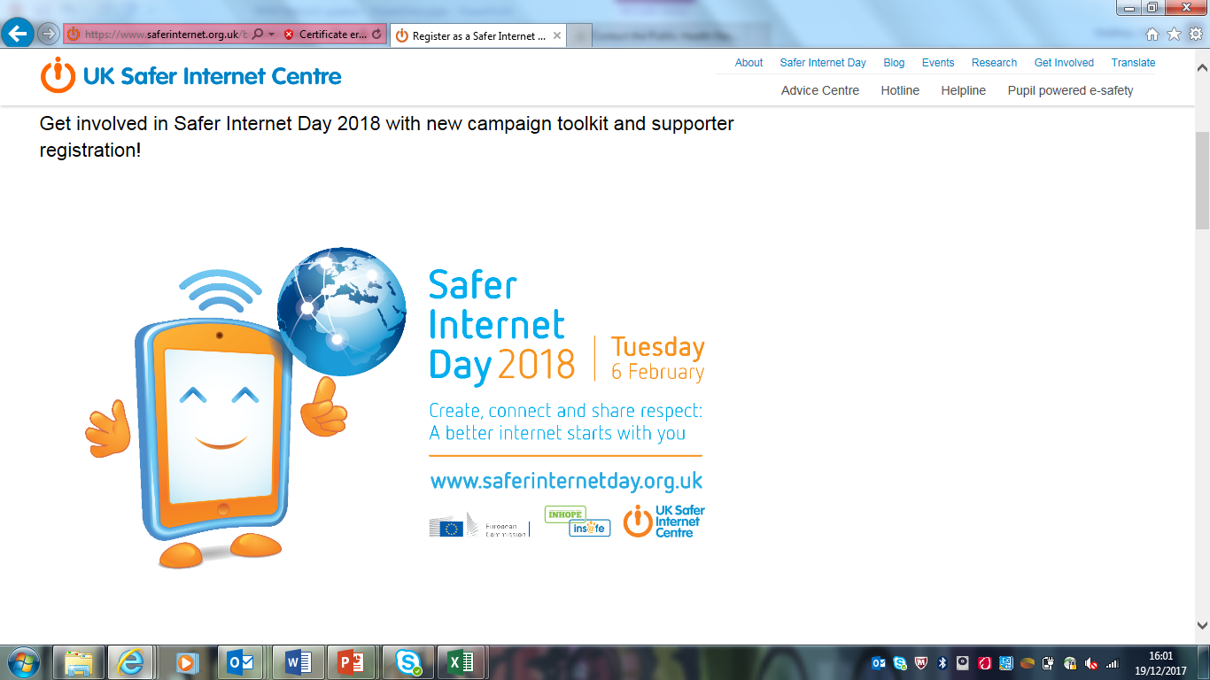

* **Safer Internet Day 2018 was celebrated globally on Tuesday 6th February 2018 with the slogan “Create, Connect and Share Respect: A better internet starts with you”.**
* **Coordinated in the UK by the**[**UK Safer Internet Centre**](http://saferinternet.org.uk/)**, Safer Internet Day sees thousands of people across the UK get involved to help promote the safe, responsible and positive use of digital technology for children and young people.**
* **Visit** [**www.saferinternetday.org.uk**](http://www.saferinternetday.org.uk/) **where you will be able to:**
* [**Register your school/organisation as a Safer Internet Day supporter**](https://www.saferinternet.org.uk/safer-internet-day/2018/safer-internet-day-2018-supporters/register-safer-internet-day-2018)
* [**Download the campaign toolkit**](https://www.saferinternet.org.uk/safer-internet-day/2018/campaign-toolkit) **to show your schools support**
* **Download the Safer Internet Day** [**Education Packs**](https://www.saferinternet.org.uk/safer-internet-day/2018/education-packs) **and view** [**the SID TV films**](https://www.saferinternet.org.uk/safer-internet-day/2018/sid-tv-2018)

**G. National CSE Day - 18th March 2018**

* **CHILD SEXUAL EXPLOITATION (CSE) IS A FORM OF SEXUAL ABUSE THAT INVOLVES THE MANIPULATION AND/OR COERCION OF YOUNG PEOPLE UNDER THE AGE OF 18 INTO SEXUAL ACTIVITY.**
* The National Child Sexual Exploitation Awareness Day aims to highlight the issues surrounding CSE; encouraging everyone to **think, spot and speak out against abuse** and adopt a zero tolerance to adults developing inappropriate relationships with children or children developing inappropriate relationships with other children.

**H.** **Change4Life campaign**

[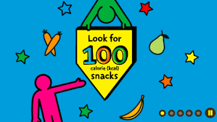](https://www.google.com/imgres?imgurl=http%3A%2F%2Fassets.change.org%2Fphotos%2F8%2Frd%2Fgr%2FSARDGrAKJnzzqPb-1600x900-noPad.jpg%3F1515161056&imgrefurl=https%3A%2F%2Fwww.change.org%2Fp%2Fpublic-health-england-change-public-health-england-s-new-100-calorie-snack-campaign&docid=A8ofh5ktTGPIAM&tbnid=UNLGnibnfYbMLM%3A&vet=10ahUKEwirvKWh5dzZAhUEwBQKHVfPAS0QMwhTKBkwGQ..i&w=616&h=347&bih=749&biw=1536&q=change%204%20life%20100%20calorie%20snacks&ved=0ahUKEwirvKWh5dzZAhUEwBQKHVfPAS0QMwhTKBkwGQ&iact=mrc&uact=8)

The Change4life latest campaign is encouraging children, parents and carers to look for 100 calorie foods. Visit the website [here](https://www.nhs.uk/change4life#b0ieJHGYrmpWaMS5.97) to view activities for schools and parents/carers as well as ways to receive chang4life packs.

* The campaign was launched on 2nd January and all primary schools that receive the School Fruit and Veg Scheme (SFVS) will have received new teaching resources and healthy eating leaflets for pupils
* Teachers can visit the School Zone section <https://campaignresources.phe.gov.uk/schools> to download these teaching resources to learn about healthy eating and snacking and lots of other useful classroom activities and presentations
* Further information about what is happening locally and what you can do to support the campaign can be accessed through the Public Health Resource Centre website [Change 4 Life: Nutrition Campaign 2018](http://www.leeds.gov.uk/c4l2018)
* The Food Scanner app will replace the Sugar Smart and Be Food Smart apps – an improved and easier to read app
* Parents will be introduced to a new simple tip – “Look for 100 calorie snacks, two a day max.”

Food detective resources are also available for KS1 and 2:

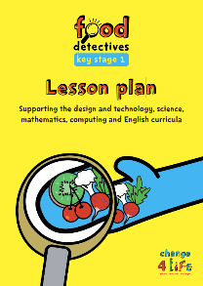 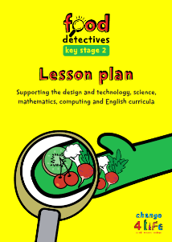

**I. Puberty and Sexuality**



Puberty and Sexuality for Children and Young People with Learning Disabilities

Children with a Learning Disability:

* Are more likely to experience challenges in their transition to sexual maturity than their mainstream peers.
* Are more vulnerable to abuse and exploitation.
* Often experience disadvantage and discrimination as a result of myths and taboos about their sexual identities

A new resource to support this vital work is available:

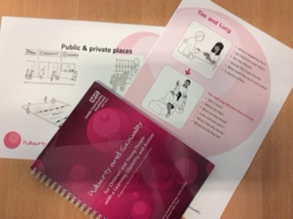

* Resource developed due to requests for support.
* Supports National Curriculum.
* Start it early!
* The 2nd edition has the Resources on the USB card and a new section on Internet safety.

**Where can I get the resource?**

* **Loan it!** - Public Health Resource Centre – Technorth.
* **Buy it!** - £25 to Leeds services.
* **Come on our course!** – You get a day of training and a copy of the resource.

Contact us on [admin.camhstraining@nhs.net](mailto:admin.camhstraining@nhs.net) for information about the next course and how to apply.

You can find further details about the training offered by CAMHS on our website; <https://www.leedscommunityhealthcare.nhs.uk/camhs/for-professionals/camhs-training/>

**J. MindMate Lessons Update**



**Focussed modules are now available to download! These are aimed at target groups who may need additional support beyond the regular curriculum. Titles include:**

* Domestic violence
* Bereavement
* Anti-stigma
* Self-harm
* Disordered Eating
* Mental Health plus

MindMate Champion registered schools can access lessons for free. To register click <https://mindmatechampions.org.uk/>

**K.  Vaccinations in schools after an unexpected outbreak of infectious diseases**

**Outbreak response - schools**

Measles is a highly infectious viral illness that can be very unpleasant and sometimes lead to serious complications. It's now uncommon in the UK because of the effectiveness of vaccination which is safe, free and effective.

Measles remains a very serious infectious disease with as many as one out of every 20 children developing pneumonia, one out of every 1,000 children will develop encephalitis (swelling of the brain) and for every 1,000 children who get measles, one will die from the complications.

**There has been a cluster of confirmed measles cases across Leeds and other major cities since October 17.**

**MMR catch up sessions have been held in 6 local schools.**

**Need to encourage the MMR vaccine**

**Measles is completely preventable through vaccination.**

**Contact Gail Evans, Advanced Health Improvement Specialist at:** [gail.evans@leeds.gov.uk](mailto:gail.evans@leeds.gov.uk)

**Please note:**

**The following information is shared but not endorsed by the Health & Wellbeing Service. We are unable to endorse any external organisation, project or programme. The decision to engage with any of the following is with your school or setting.**

**L. External Delivery: Refugee awareness workshops for schools – Nola Ellen**

Nola Ellen is a Youth Work Practitioner, Educator and Trainer specialising in promoting the inclusion and wellbeing of children from asylum seeking and refugee backgrounds. Nola delivers practice based refugee awareness workshops and talks for primary, secondary, sixth forms, colleges and SILC’s. More information at:

<https://www.nolaellentraining.co.uk/refugee-awareness> or email [nola@nolaellentraining.co.uk](mailto:nola@nolaellentraining.co.uk)

​Nola recently co-founded ‘My Bright Kite CIC’ is a specialist not-for-profit organisation based in Leeds. My Bright Kite offers tailor made group work programmes to support children from asylum seeking and refugee backgrounds to feel welcome and settled in schools and their wider communities. Programmes are built around the holistic needs of children with a key focus on social inclusion, emotional health and wellbeing. For more information please visit: <https://www.mybrightkite.org/>   or contact Nola at: [hello@mybrightkite.org](mailto:hello@mybrightkite.org)

[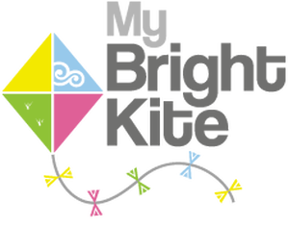](https://www.mybrightkite.org/)

**M. External Delivery: One Day Creative**

One Day Creative is an innovative Creative Education company that prides itself on connecting learning with creativity and imagination. Alongside our many core curriculum workshops, we also deliver issue-based workshops and performances to tackle difficult topics in a fun and engaging way. Online Safety and Mindfulness and become one of our most popular strands, and we now offer interactive workshops from EYFS to Secondary, as well as touring performances for KS1 & 2. Our workshops have been developed using a blend of creative workshop techniques, drama exploration and mindfulness to explore and encourage healthy emotional well-being. Pupil input and creative ideas are used by our experience facilitation team to create workshops that allows them to learn new skills whilst having fun and participating in something interactive. We can work with up to 140 pupils per day in workshops, and 200 per performance.

[sarah@onedaycreative.com](mailto:sarah@onedaycreative.com)

01937 206 064

**N. Always and Tampax ‘About You’ Puberty Education Programme.**

[](https://www.always.co.uk/en-gb)

By registering you will get access to a wealth of downloadable lesson plans, videos and in-class activities, as well as **#LikeAGirl confidence-building resources** to help you deliver key curriculum topics. Click the image above to go to the website

[About You](https://www.always.co.uk/en-gb/puberty-education-programme-always-tampax)

**A reminder of what you will receive:**

* Classroom demonstration kits
* **Feminine protection sample packs** & information booklets **for the girls**
* Parent/carer leaflets for the girls to take home

(You can order a year group per school so up to 200)

[**Click here**](http://m3.marketlayer.com/m/tl.php?p=pbw/406/rs/auz/sd/rs//http%3A%2F%2Fwww.nationalschoolspartnership.com%2Fpubertyeducation.php%3F%3D%26amp%3B%3D%26amp%3Butm_source%3DNSP%26amp%3Butm_medium%3DEmail%26amp%3Butm_campaign%3DPGA3%26amp%3Butm_content%3DPGA3-024)**to request the number of free sample packs you need!\***

Date of next meeting: