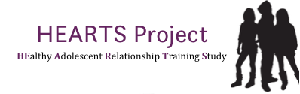

Expression of interest
to participate in the HEARTS project

If you are interested in taking part in the HEARTS project pilot-RCT, please complete the form below and return to Trish Conning (E: trish@arieltrust.com).

We will then follow up to tell you more about the project and ask you some questions before we formally sign you up to take part.

I am interested in participating in the HEARTS project pilot-RCT and understand that my involvement will require:

- Assisting in the collection of active parental consent for pupils to take part in the research project (until February 2016 the latest)

- Teachers completing Ariel Trust’s training on the FaceUp resource in the Spring term 2016

- Delivery of FaceUp in full, for the first time, during Summer Term 2016 in PSHE

- Flexibility to deliver FaceUpin either Year 7, 8 or Year 9 depending on random allocation of the HEARTS project (Year 9 for the intervention group and year 7 or 8 for the comparison group)

- Separate teachers teaching Year 7/8 and Year 9 in PSHE

- Collecting online data from all pupils in Year 9 at three time-points (Feb/March 2016; Jun/Jul 2016; Feb/March 2017)

- Teachers of Face Up completing a lesson checklist after each Face Up lesson to indicate what was delivered and teachers in intervention and comparison schools providing some further information what PHSE lessons have covered for Year 9 pupils.

Name (and position):

School:

Signature:

Date:

Phone:

Email:

