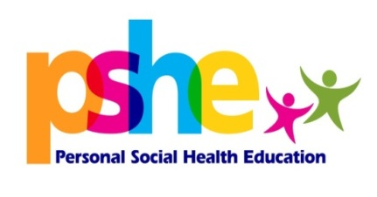
Promoting young people’s wellbeing is a statutory duty placed upon all schools. The OFSTED inspection framework recently introduced a new judgement that focuses on personal development, behaviour and welfare and requires schools to promote this through a broad and balanced curriculum.
The Health and Wellbeing Service are currently offering direct delivery support to pupils around a range of primary relationship and sex education topics.
Positive Relationships
Research shows that prevention work in schools focusing on domestic abuse should start at or prior to the age 11, before attitudes begin to harden.
The aim should be to prevent violence from being a feature in their lives, rather than to intervene after the event. (NUT, 2005)
This one hour session aimed at both male and females uses activities adapted from a range of quality resources and begins to explore the issue of unacceptable behaviour within relationships.
By the end of this session young people will be able to:
- identify positive qualities within a relationship
- recognise common gender stereotypes
- recognise acceptable/unacceptable behaviours
- understand the importance of not keeping secrets
- identify sources of support
For further information on any of the sessions or to make a booking please contact Emma Newton on: 07891 276623 0113 3951076 OR by email emma.newton@leeds.gov.uk
Social Media
Social media is fast becoming an integral part of every day. A recent survey found that 98% of 8-11 year olds have an active social networking site profile on Facebook.
This session explores the positive and negative aspects of online use and the impact social media is having on young people today.
By the end of this session young people will:
- be able to identify the positive/negatives of online use
- be able to identify the impacts of social media on young people
- identify ways to keep safe online

Puberty/Puberty & Conception
Going through puberty can be a confusing, difficult time for some children. Talking through both the physical and emotional changes can help to alleviate some of the worries they experience and help them to grow in confidence.
This session gives children the opportunity to explore some of the changes they may experience and includes information on body changes, periods, mood swings and a brief overview of the conception process.
By the end of the session young people will be able to:
- identify different parts of the male and female anatomy
- recognise the physical & emotional changes that happen during puberty
- describe the process of menstruation
- understand the process of conception
Body Image
A recent study showed that at the age of 10, around a third of all girls and 22% of boys, say how their bodies look is their number one worry.
Media, advertising and celebrity culture all have a significant impact on the way children and young people view themselves.
This one hour session explores the various influences impacting on children in relation to body image with a particular focus on the media.
By the end of this session young people will:
- be able to identify factors impacting on body image
- have gained an understanding of advertising/media techniques used to alter images
- have developed an understanding of how media impacts on self esteem

