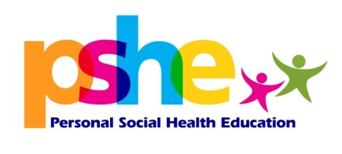

Order form:
Primary PSHE Prevent lessons Years 5 & 6

If you wish to pre order the CD or the full resource of the CD and accompanying book please fill in the form below and return to schoolwellbeing@leeds.gov.uk

CD and book ‘And tango Makes 3’ | Price of resource: | Please indicate your requirements:
CD only | £20.00
CD and book | £25.00

School/Academy name:
School/Academy address:
Contact person:
Contact email:
Contact number:
Headteacher name:
Headteacher approval:
Cost code or order:
Please return this form to: schoolwellbeing@leeds.gov.uk

