
Leeds Theatre in Education Company
Parklands Primary School
Dufton Approach
Leeds, LS14 6ED
Telephone: 0113 2649657
Website: www.leedstie.co.uk
Email: theatreineducation@hotmail.com

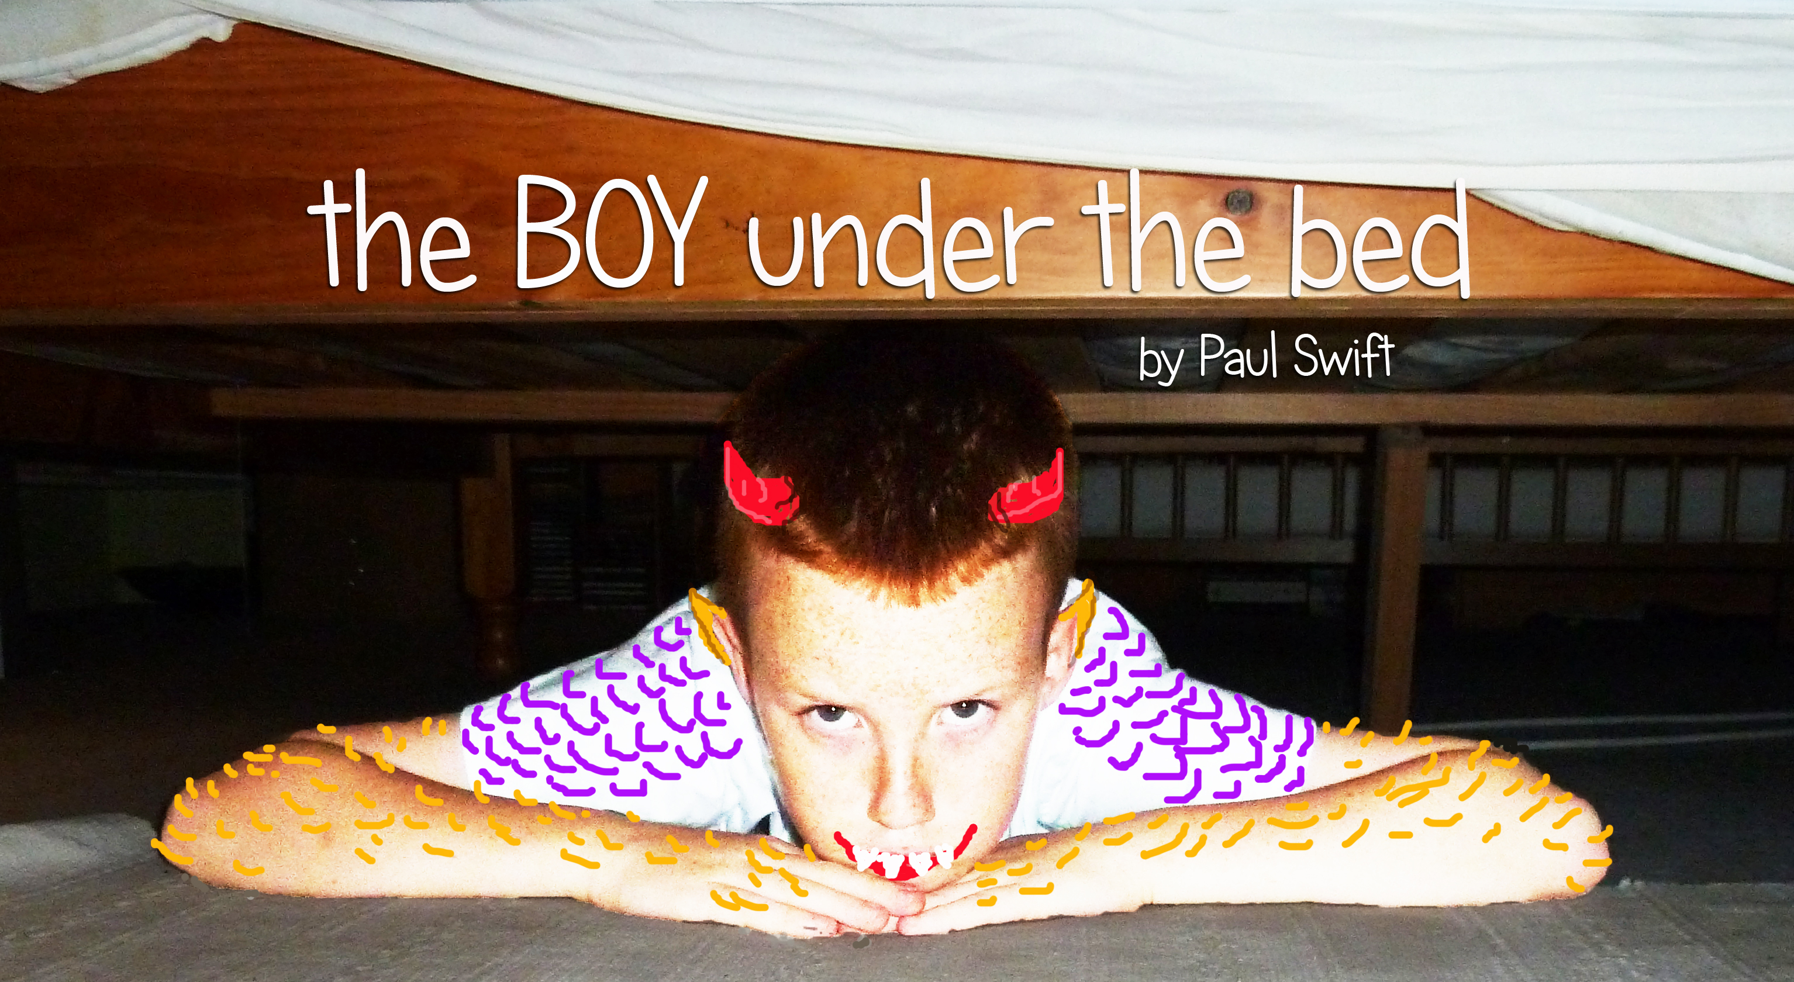
The boy under the bed is very bad.
He smacked my mum and made her sad,
He breaks my toys so I can’t play.
I wish that boy would go away!

the BOY under the bed tells the story of 5 year old Josh and his family. The story begins when Josh is alone in his bedroom with his toys…
“I’m not scared. I like being on my own, cos I can just play. I’m playing Simba. He’s a lion, but he’s only little, and he’s all on his own cos he’s lost his mum and his big sister in the dark scary woods. ‘Will you go with me into the dark scary woods and help me find my mummy?’”
Then Josh’s Nana comes…
“The pitch was perfect! You had my entire class gripped from the beginning of the performance to the end of the workshop.” Teacher
“It made the children think about the issues. They were able to discuss the deeper issues in class that they wouldn’t usually be able to talk about.” Behaviour Support
the BOY under the bed is part of an educational theatre programme that supports work on health & wellbeing, divided families, domestic violence & mental health issues. The programme consists of the participatory play (40 - 45 minutes), post play discussions, workshops and Teaching Support Materials, and is available for Years 4, 5 & 6.
“Thrilled with the work you did with Year 4 last week; you certainly brought out the best in them and enabled them to explore challenging but really pertinent issues. The quality of experience that you bring into school is so rare – long may it continue!” Head Teacher

Our programmes are designed to enable classes to talk safely about sensitive issues relevant to their lives, increasing empathy and understanding of their own and others’ experiences; to engage all pupils, including those who don’t normally engage and to enable every child to participate at their own level; to draw on and validate the experience and knowledge of pupils, raising confidence & self-esteem and having a positive impact on learning and behaviour.

By Paul Swift

