Make time for your mental health
Healthy Minds Group
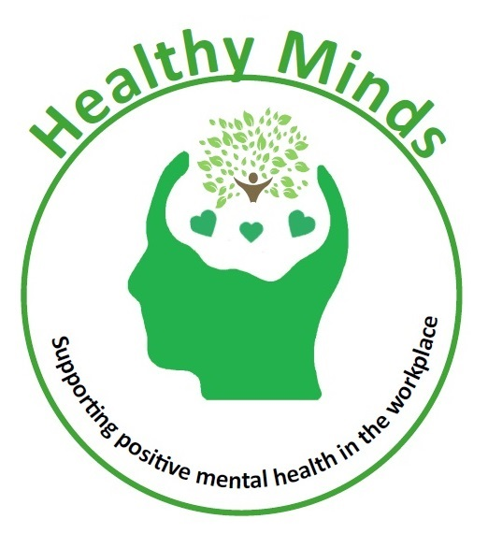

The Healthy Minds Group is all about supporting positive mental health in the workplace, and encourages LCC staff to make time for their mental health. The group meets once a month and creates a safe, non-judgemental space.

Employees are entitled to time off to attend these meetings (up to 2 hours per month). If you would like to attend, please contact us at Healthy.Minds@leeds.gov.uk so we know you are coming and can add you to our mailing list.
Future meetings
Date | Time | Venue
Tues 24th January | 10.30 – 12.00 | The Millennium Room,  The Carriageworks Theatre
Fri 17th February | 2.30 – 4.00
Thurs 16th March | 10.30 – 12.00 | Room 1, The Carriageworks  Theatre
Mon 10th April | 11 – 12.30 | The Millennium Room,  The Carriageworks Theatre
Tues 9th May | 12 – 1.30
Please email Healthy.Minds@leeds.gov.uk to be added to our mailing list and
stay up to date with all meeting arrangements.

